4.30: a) The stopping time is 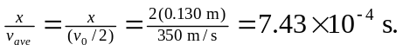
b) 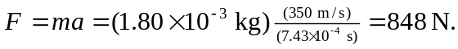 (Using 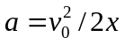 gives the same result.)

